Name: V.Siri Chandana
Roll No: 2520030609
Section:2
Subject:DBSE & DBD
SKILL SESSION NUMBER 4 AND 5
MONGODB ATLAS - BANK TRANSACTION DATABASE
EXPERIMENT TITLE:
Bank Transaction Management Using MongoDB Atlas Data Explorer
OBJECTIVE:
To create a bank database using MongoDB Atlas, store customer
and transaction information in separate collections, perform
queries similar to SQL JOIN operations, and execute complex
transaction-analysis queries.
PLATFORM:
MongoDB Atlas
MongoDB Atlas Data Explorer
DATABASE:
bankdb
COLLECTIONS:
1. Customers
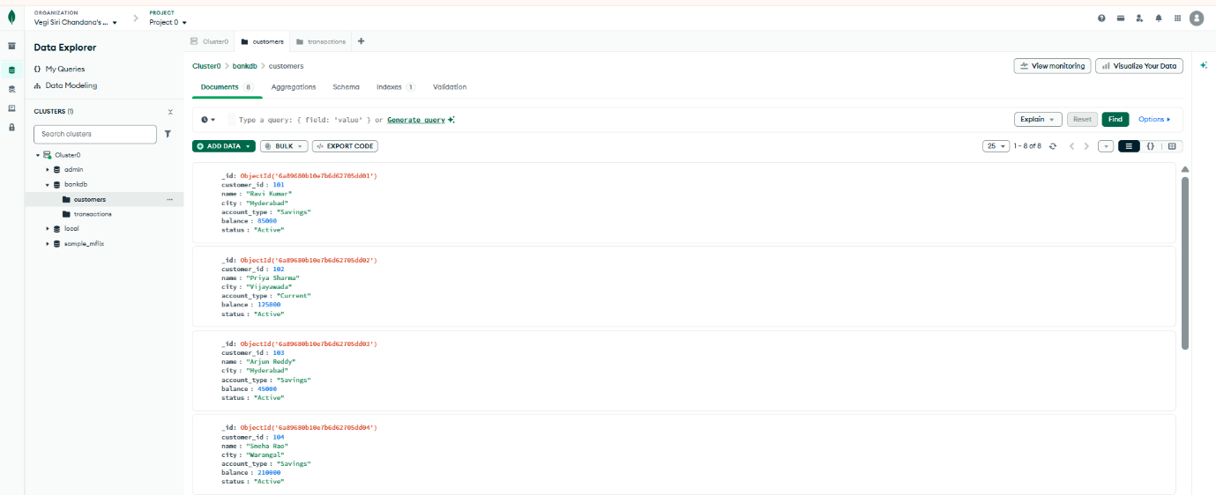
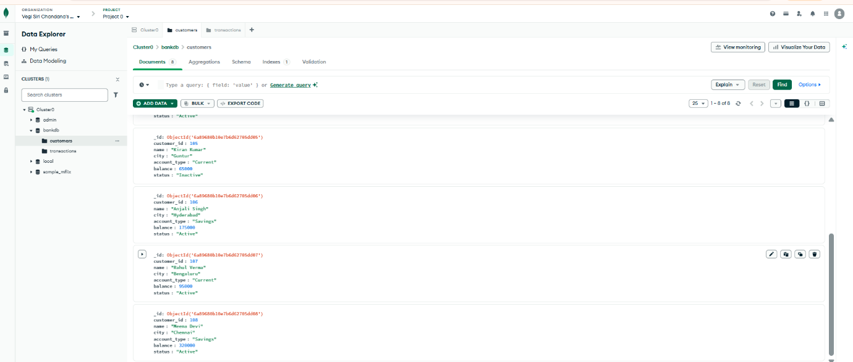
2. Transactions
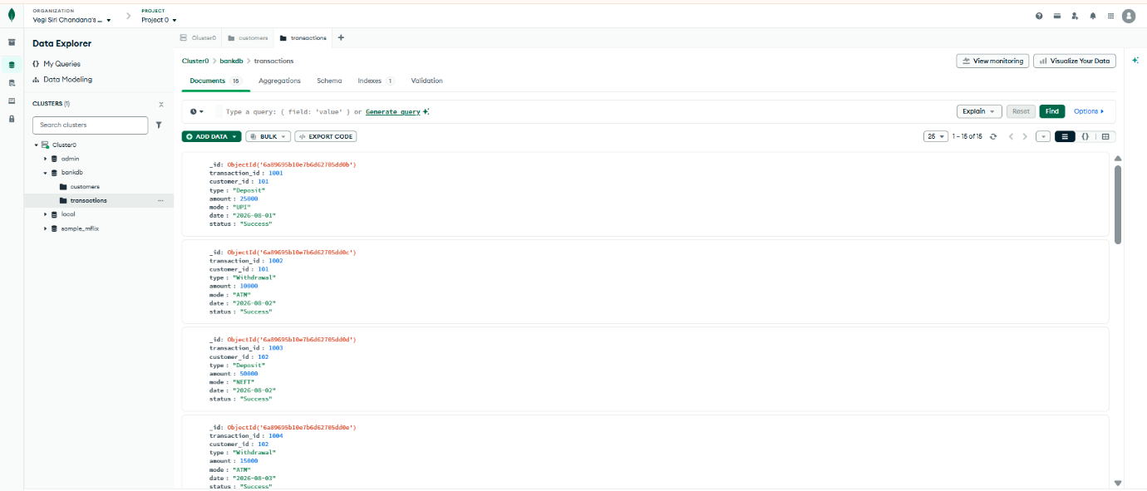

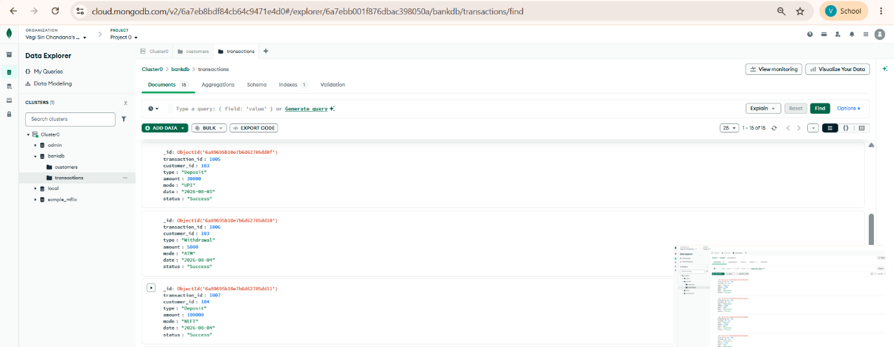

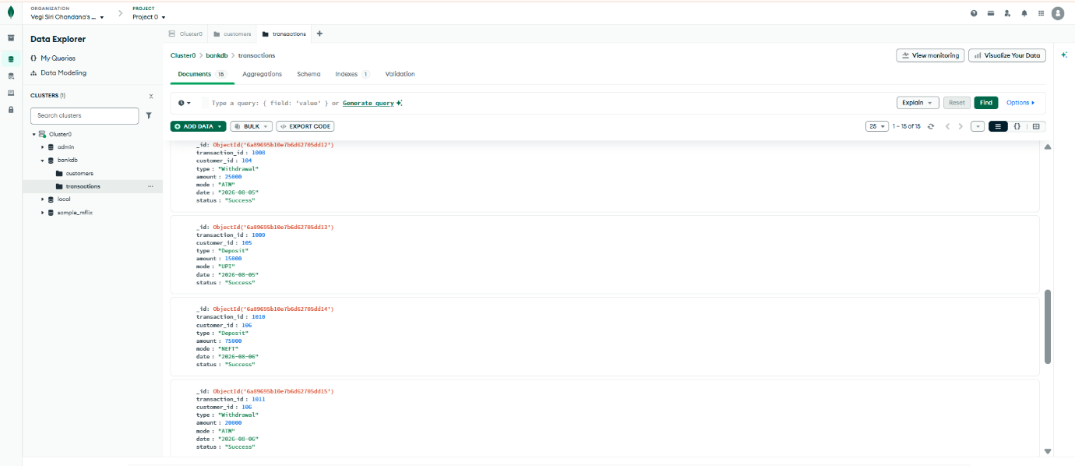

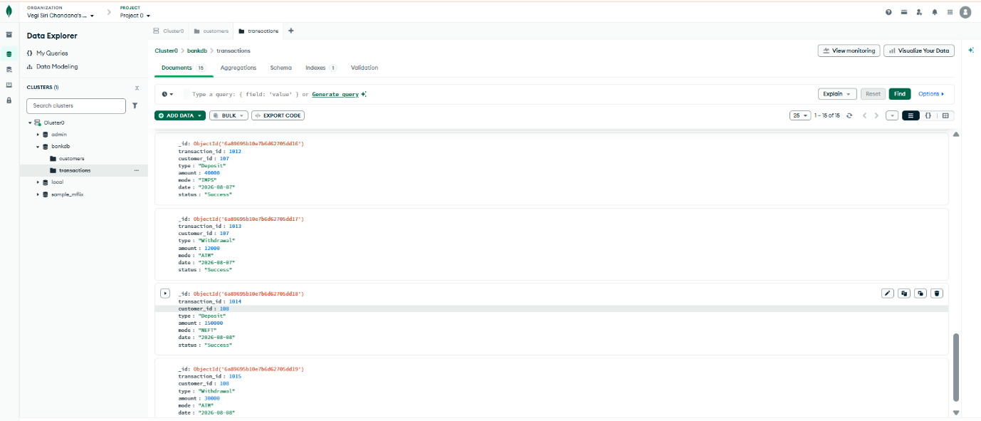

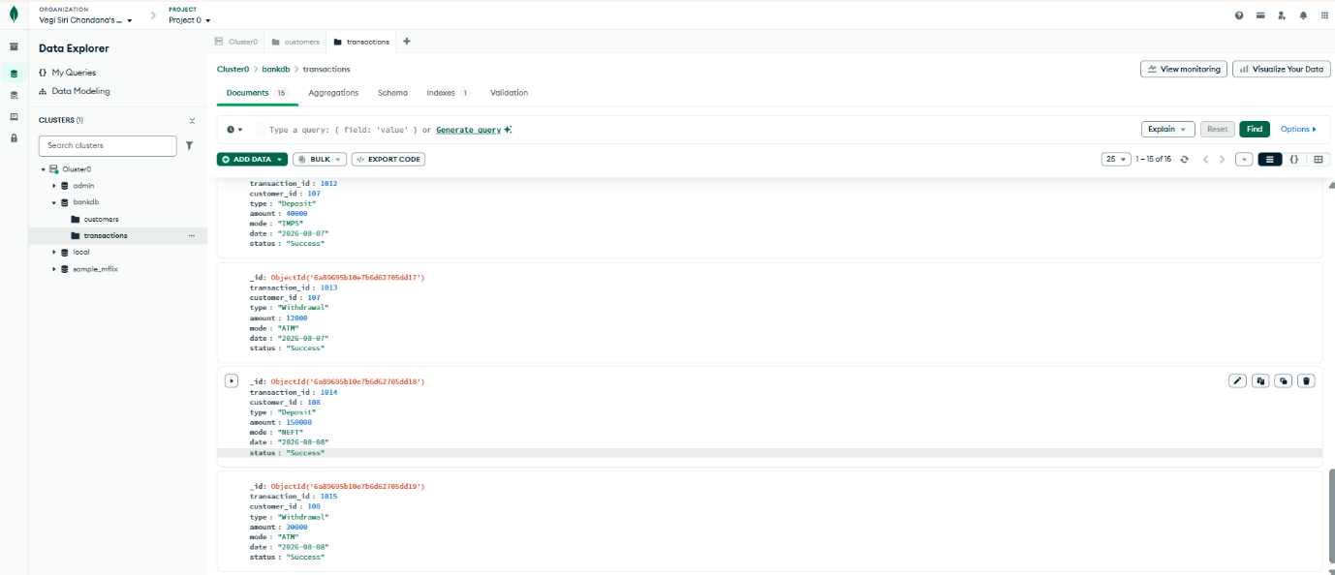

QUERY 2: FIND ACTIVE CUSTOMERS
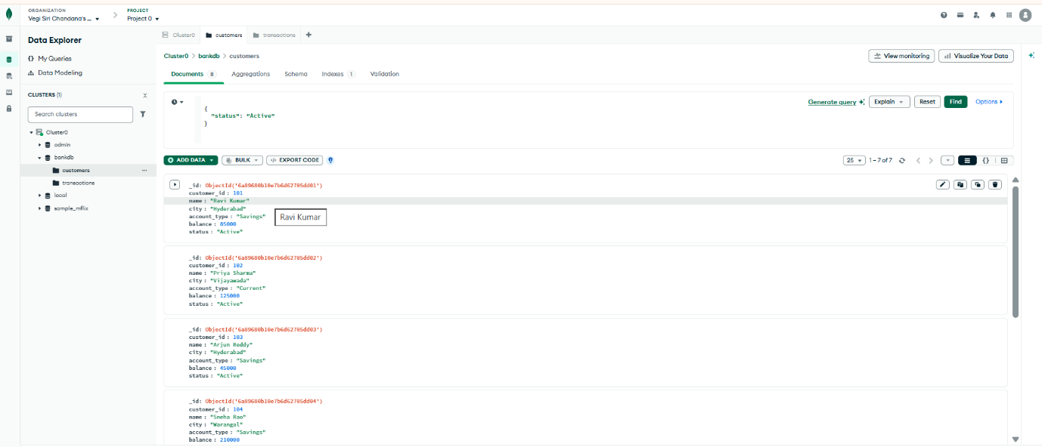
QUERY 3: FIND CUSTOMERS WITH BALANCE GREATER THAN 100000
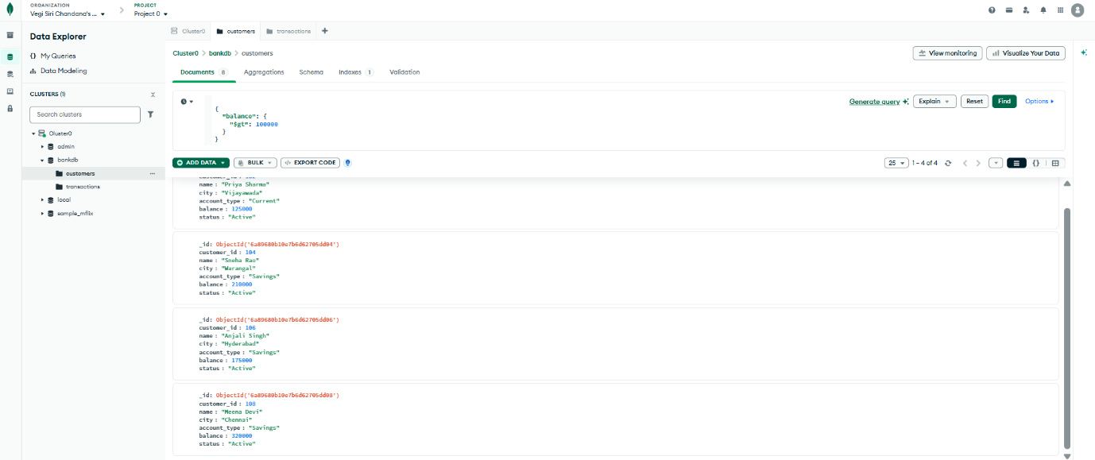
QUERY 4: FIND HYDERABAD CUSTOMERS
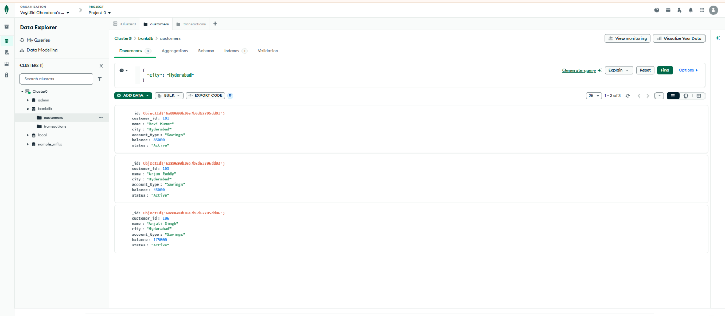

QUERY 5: FIND SAVINGS ACCOUNT CUSTOMERS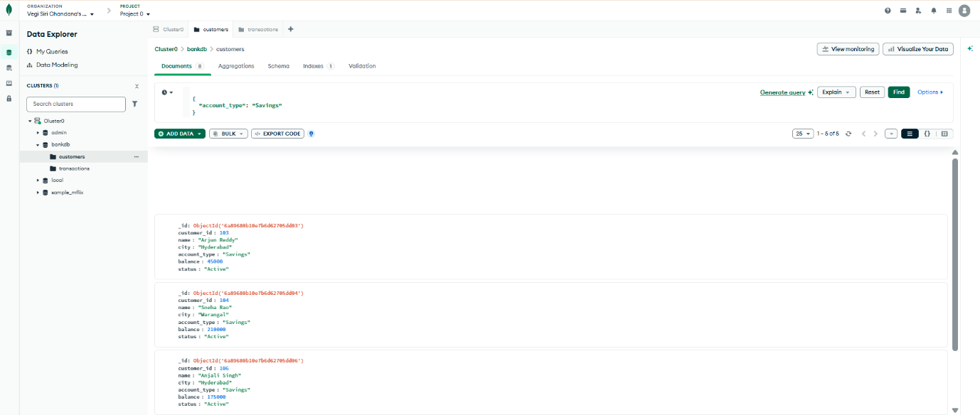
QUERY 6: FIND TRANSACTIONS GREATER THAN 20000
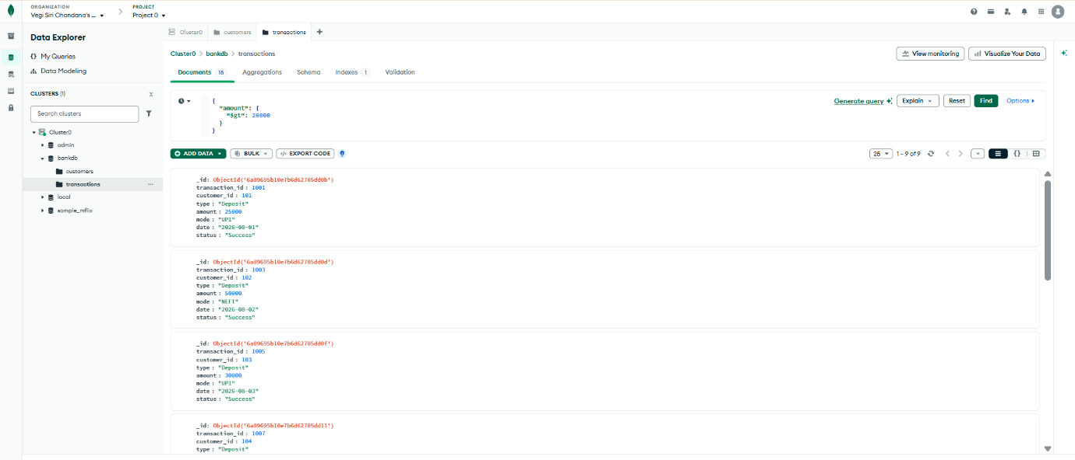
QUERY 7: FIND DEPOSITS
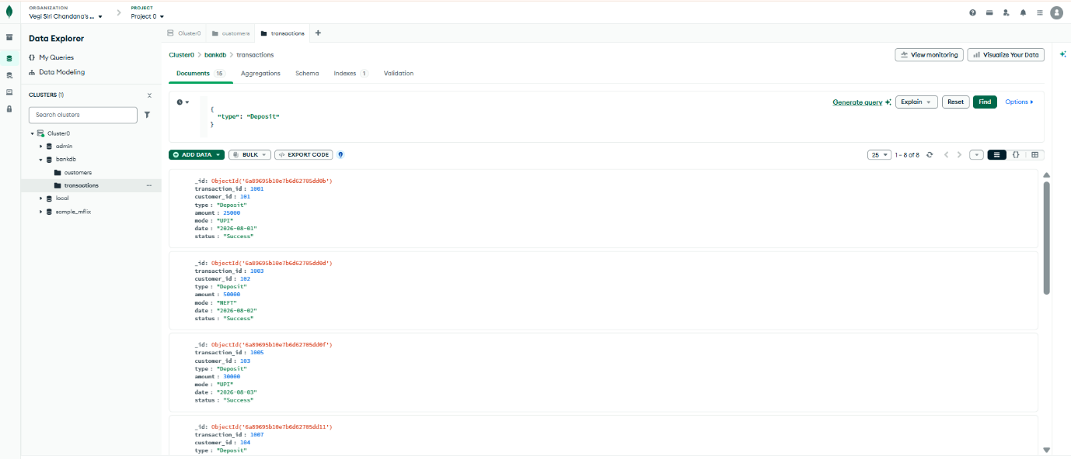

QUERY 8: FIND ATM TRANSACTIONS
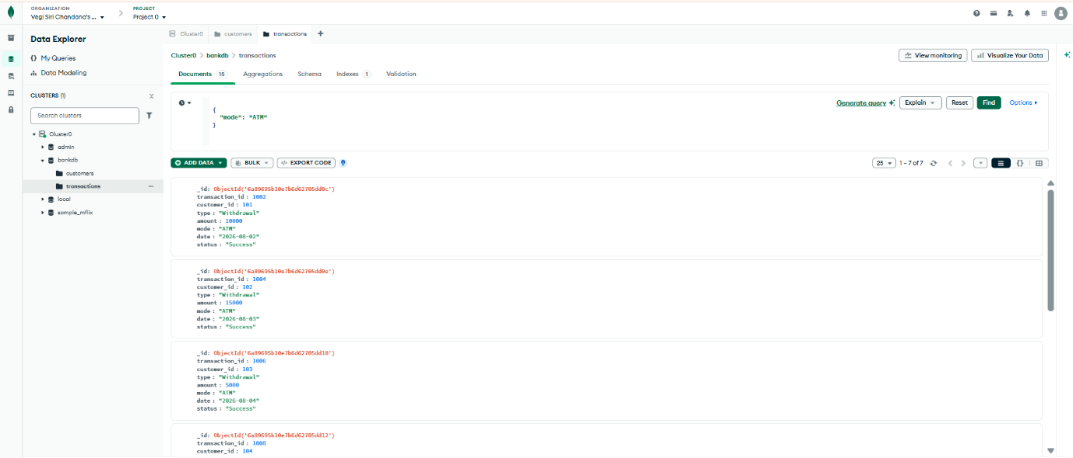
QUERY 9: FIND DEPOSITS GREATER THAN 50000
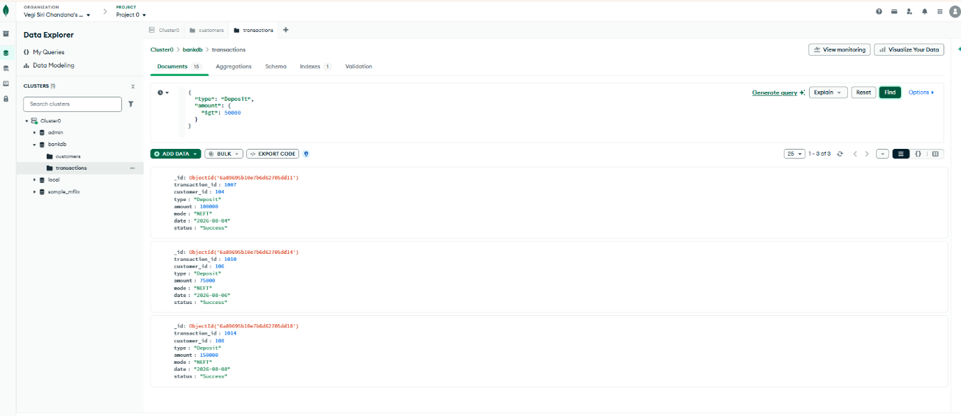
QUERY 10: FIND HYDERABAD CUSTOMERS WITH HIGH BALANCE
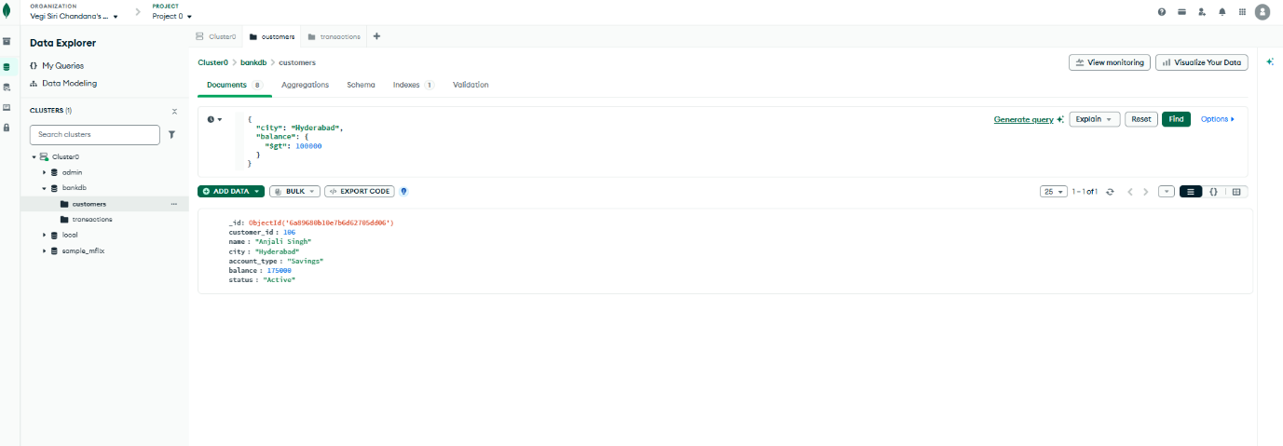

QUERY 11: FIND CUSTOMERS IN MULTIPLE CITIES
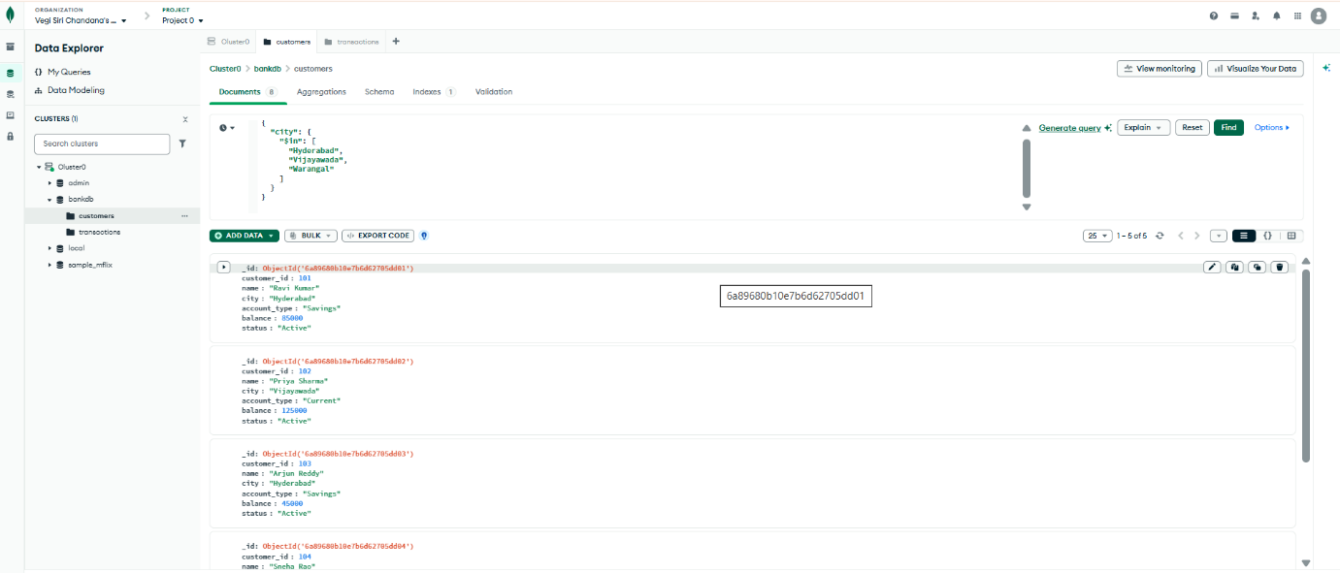
QUERY 12: SORT CUSTOMERS BY BALANCE
Aggregations:
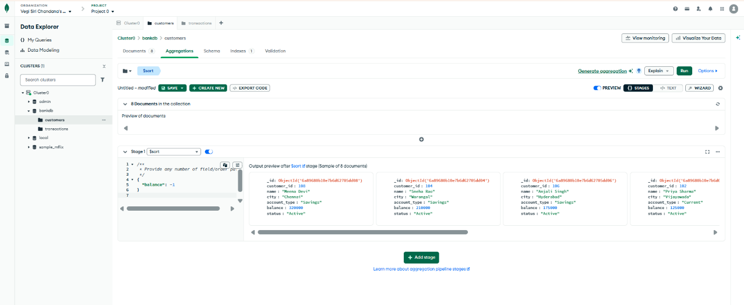

QUERY 13: CALCULATE TOTAL TRANSACTION AMOUNT
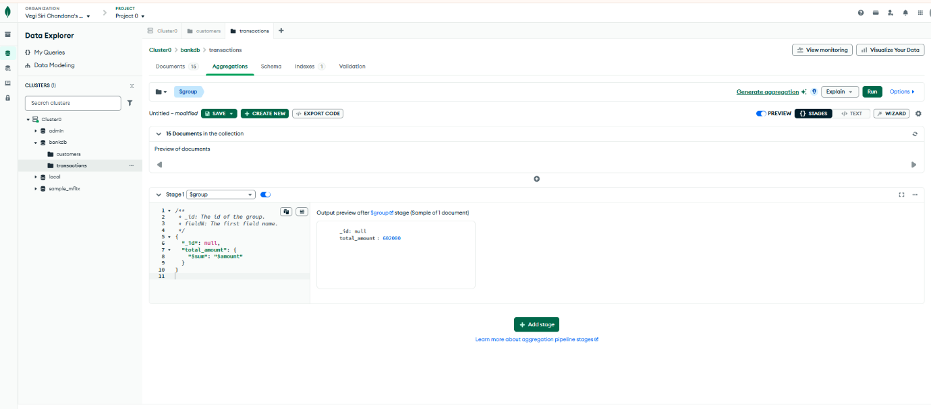
QUERY 14: CALCULATE AVERAGE TRANSACTION AMOUNT
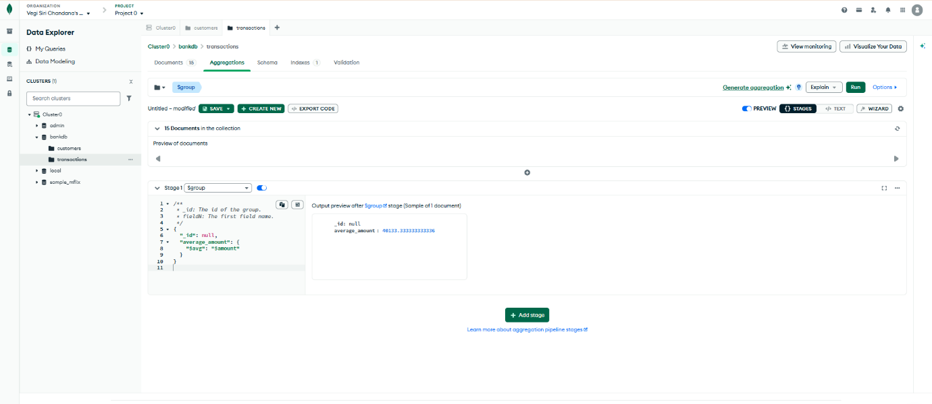
QUERY 15: TOTAL TRANSACTION AMOUNT BY TYPE
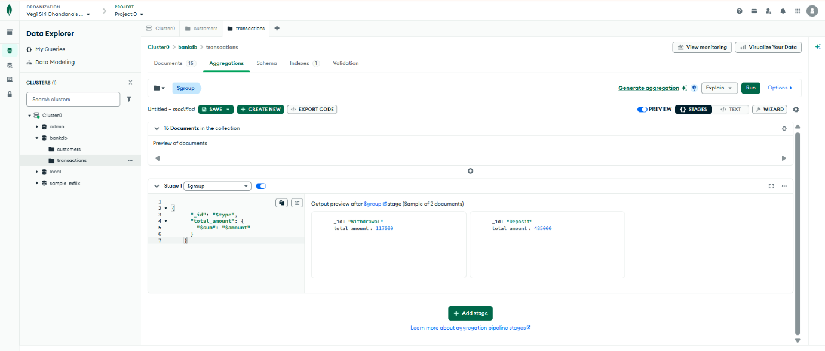
QUERY 16: NUMBER OF TRANSACTIONS PER CUSTOMER
